HORACE GRANT P. SAQUING
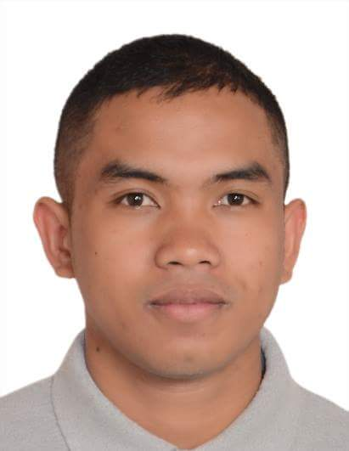
7-Alve road, Tiakitahuna, Opiki
ace.saquing@gmail.com
Skype I.D: aceshot99
02108444304/+639266887843
_________________________________________________
Profile:
Age: 27
Sex: Male
Birthday: August 13, 1991
Birthplace: Valencia City, Bukidnon
Civil Status: Single
Height: 166 cm
Weight: 69 kg.
Religion: Born Again
Nationality: Filipino
Hobbies: Playing Basketball and Chess

Objective:

To obtain a position where I could apply, utilize and improved my potentials, skills, knowledge, work and training experiences

Educational Attainment

Bachelor of Science in Agriculture Major in Animal Science, Central Mindanao University, March 19, 2012

Special Course in Dairy Production and Management, Central Mindanao University, 2012-2013 (6 months training)

Work Experience

Hopkins Farming Group (Tollbridge Farm)
Dairy Farm Assistant
March 12, 2018 to Present

Duties and Responsibilities

- Milking Cows
- Fences
- Irrigation/Effluent Running
- Weeding
- Shed Maintenance and Cleaning
- Calf Rearing
- Assist in Calving of Cows

Al Hamra Dairy Farm (Almarai Company)
Milking parlour Supervisor
October 2016 to October 2017

Duties and responsibilities

- Daily checking of all the staffs (proper milking routine and hygiene)
- Daily, weekly and monthly reports
- Calibration of equipments
- Ensures that all activities in the milking parlour are carried out (milk samples, backflush and teat spray testing are sent to the lab) and monthly rubber wear change
Al Hamra Dairy Farm (Almarai Company)
MTO (milk transfer operator)
April 2016

Duties and responsibilities

- Proper handling of milk (ISO-22000)
- Raw milk quality checking
- Delvo test (antibiotic test) and Chemical testing (titration test)
- CIP of Silo’s, Balance tank, and milk pipes
- Record keeping
- Chemical Handling

Al Hamra Dairy Farm (Almarai Company)
General Farm Worker/ Milker
October 2014

Duties and responsibilities

- Assemble cow’s in the wash pen
- Move to drip pen
- Move to platform
- Strip foremilk (check mastitis)
- Attached clusters properly
- Check liner position
- Spray teats after milking with iodine
- Release cows
- Hose of dirt
- Keeping the whole milking parlor clean

Skills

- Good Animal Handling
- Shed Basic Maintenance and cleaning
- Raw milk quality testing
- Computer literate
- Post and fence
- Detection of Mastitis and Sick animals

Trainings & Seminars

-Primary ITO Level 3
- Milk quality Stage 1 and Food Safety
- Dealing with on Farm Effluent
- Milk Smart

-2IC or Assistant Manager Development Program (on-going)

Reference

- Iain Black
Supervisor
Hopkins Farming Group
0212460298

- Michael Le Marquand
Manager
Hopkins Farming Group(Tollbridge Farm)
0277539558

- Daryl Secong
Assistant Dairy Farm
Mitchell Milky Way Ltd.
Scarborough Road, Pahiatua, New Zealand
02108443875

