Curriculum Vitae

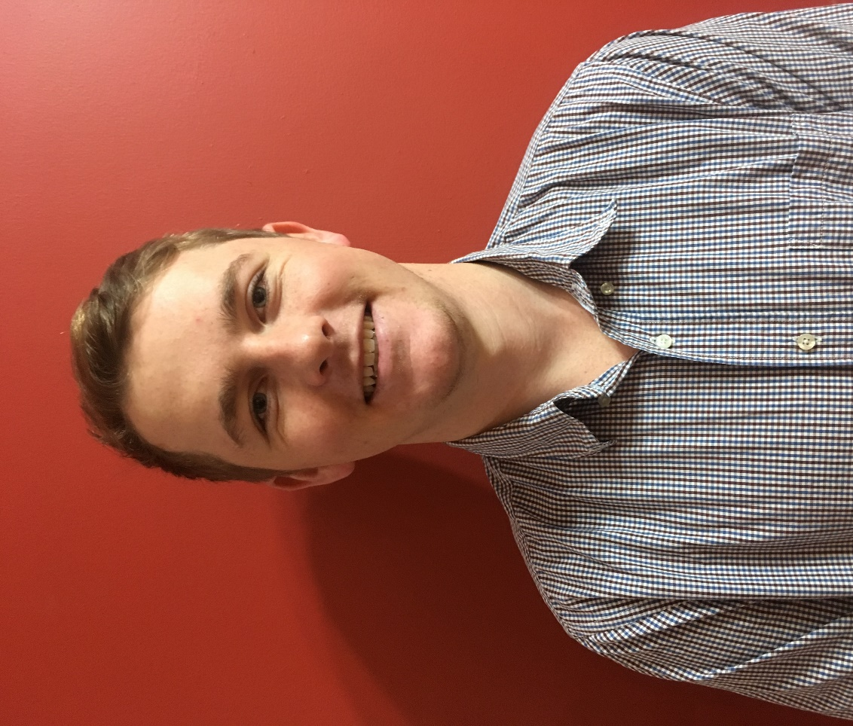

Darren James Hirschberg
Address: 1480 Makoura Road
Utuwai RD 14 Ashhurst

Mobile: 0279193715
Email: darrenhirschberg@gmail.com

DOB: 28/10/1998

Personal statement
I have just entered my third year of university at Massey studying a Bachelor of
Agri-Commerce Majoring in International Business. So far university life has been a great experience meeting lots of new people, and learning lots of new skills, like the value of networking. I was born and raised in the Manawatu growing up on the family sheep and beef farm located at the top of the Pohangina valley.

Skills

Time management
- While studying it is very important to have a good time management plan to get assignments done on time, and to a high standard.
- Organisation has been put into practice through the Massey young farmers club, by volunteering to help at event’s, and fundraising opportunities for the club.
- Work experiences over the semester breaks have taught me good optimisation of time skills. Keeping me focussed to always be on time, complete the tasks in an efficient manner, and to always be looking to exceed expectations of an employer by doing the job well, and asking questions where needed .

Problem solving
- I value these skills highly and believe they are integral to learning.
- University is always challenging problem solving skills. Some weeks I might have lots off assignments due so any spare time is used to problem solve, and then complete them to a high standard.
- Working at Grassmere Dairy Farm, over a summer semester break management always channelled us to try solve problems ourselves, this taught us resilience and new practical skills in the process.

Work ethic
- Over the past 4 summers I have spent time shearing. I believe these experiences have improved my work ethic due the physicality of the job and the mental strength you need to finish the job to a high standard.
- Working for family, friends and neighbours has drilled a good work ethic into me. I have learnt to become a reliable asset to their business in the jobs I have been able to do. There have been good learning outcomes for my prospective employers as I learn to negotiate my way to being a constructive reliable employee in the future.

Work history
General Farm Hand, Grassmere Dairy Colyton:
During the 2017-2018 summer, I worked as a general hand at the dairy farm.
My role at the farm was to undertake every day activities such as fencing, irrigation, getting cows in etc. I learnt lots of new skills such as
- General knowledge of a dairy farm system.
- Team work skills
- Gained a list of valuable contacts.
- Work ethic demonstrated by working from 4am till 5pm continually 5-6 days a week.

Casual Farm Hand, Steve Hirschberg, Pohangina Valley
During school holidays I worked for Steve as a general farm hand. Jobs that I did included,
- Fencing
- Drenching
- Crutching
- Shearing
- Tractor driving
- Spraying

Casual work over school/university holidays
Gordon McIntyre, Pohangina Valley
- Shearing

John Birchler, Pohangina Valley
- Shearing

Cheryl Hirschberg, Pohangina Valley Scanning Services
- Sheep Scanning

Grant Paton, Pahiatua Shearing Contractor
-Shearing

Achievements

- NCEA level 1,2,3. Palmerston North Boys High School.
- Year 13 Mentor for year 9s.
- 2015 5 day shearing course which gave me Level 1 and 2 in shearing, crutching and wool handling.
- 2016 Prefect College House.
- Competed at world triathlon champs in Mexico 2016, as part of the New Zealand age group team.
- Completed my first half iron man in 2016.
- Awarded an honours tie in my final year at Palmerston north boys’ high school.
- Attended The Mind Body Soul course at outward bound in 2016.
- Awarded the “No Bull” award from Massey University Young Farmers for contribution to the club 2018.
- Made the semi finals in the 2019 Apiti Junior Shears.

Education
- NCEA level 1,2,3
- Attendance to 3 Massey young farms skills day
- 9 papers at 100 level Massey University
- 6 papers at 200 Level Massey University

Interests and hobbies
My entire life has been very active growing up playing rugby, hunting, tramping, fishing, snow and water skiing. I have completed the Abel Tasman, Heaphy, Waikaremoana, and Tongariro Circuit Great Walks. To this day I still live a very active lifestyle, currently playing rugby for Varsity. Any spare opportunities I have I’ll be out there hunting, surfing, mountain biking and plenty of other activities.

Referees

Rob Kopic
Farm manager at Grassmere Dairy
Phone: 021 086 46528

Gordon McIntyre
Farm owner
Phone: 06 3284 878

Grant Paton
Shearing contractor
Phone: 027 447 58832

