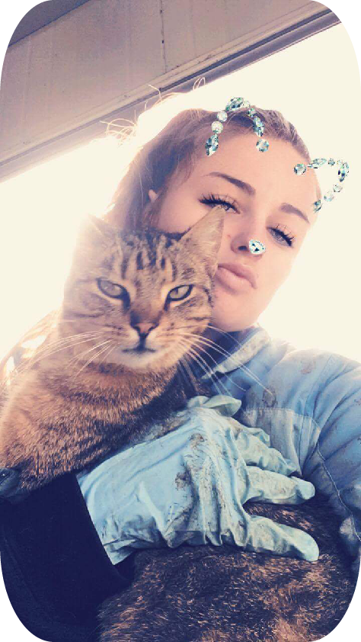
Karley Williams
Miss
Dob:25/08/1998
Have a current drivers Lisence
My own Transport
1 Paul Drive, Ngatea mzkayvatos@gmail.com  0284101606 | Love music, cooking food, being creative and having a good time.Love animals and being around animals. Kind, Bubbly Personality, Eager to learn new things and Always get the job done, Very Committed and Motivated by what I do.
Experience | Support Worker
.

Norwood Community Services
April 2016 - August 2016
Worked Full time as a Support Worker for a young 18 year old girl, Maintained the need and safety of my client and ensured her daily needs were meet, and was a great team player.

Kiwifruit Picking
Te Puke
2015 - 2015
Worked Full time only seasonal picking Kiwifruit in a Orchard in Te Puke

Thai Restaurant
Paeroa
2015
Worked Part Time as Waitress for a Thai Resturant in Paeroa, Served food, Took Request, Cleaned and Prepped food.

Farm Assistant
Taniwha Estate
July 2017 - August 2017
Worked Full time as Farm Assistant for Seasonal Only. Rearing Calves, Milking in a 52 Bale Rotary, Done Fencing and A lot of Cleaning

Farm Assistant
Robbie Singh
August 2017 – July 2018
Working Full time as Farm Assistant, Bringing Cow’s Up, 2 wheeler and 4 Wheeler, Cleaning Shed, Weed control & Spraying, Milkings, Fencing, Treating Sick Cows and Rearing Calves, Setting up Breaks in the paddock, Fixing Water trough
 This resume is made with Free Resume App

Education High School
Thames High School 2012

Mathmatics/English/Pe/Health Ed
Te Kura Online Correspondence
2017 - 2017
Studied Full time Online With Te Kura

This resume is made with Free Resume App

